Query 1: Create the database
Query 2: Select the database 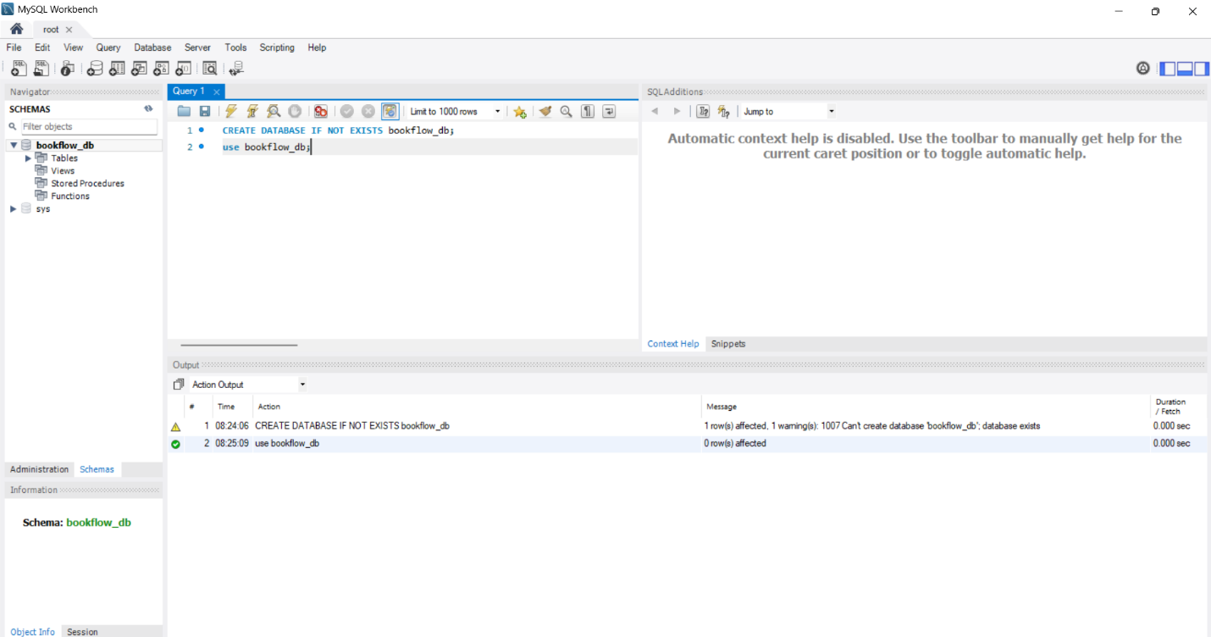Query 3: Create the books table
Query 4: Create the members table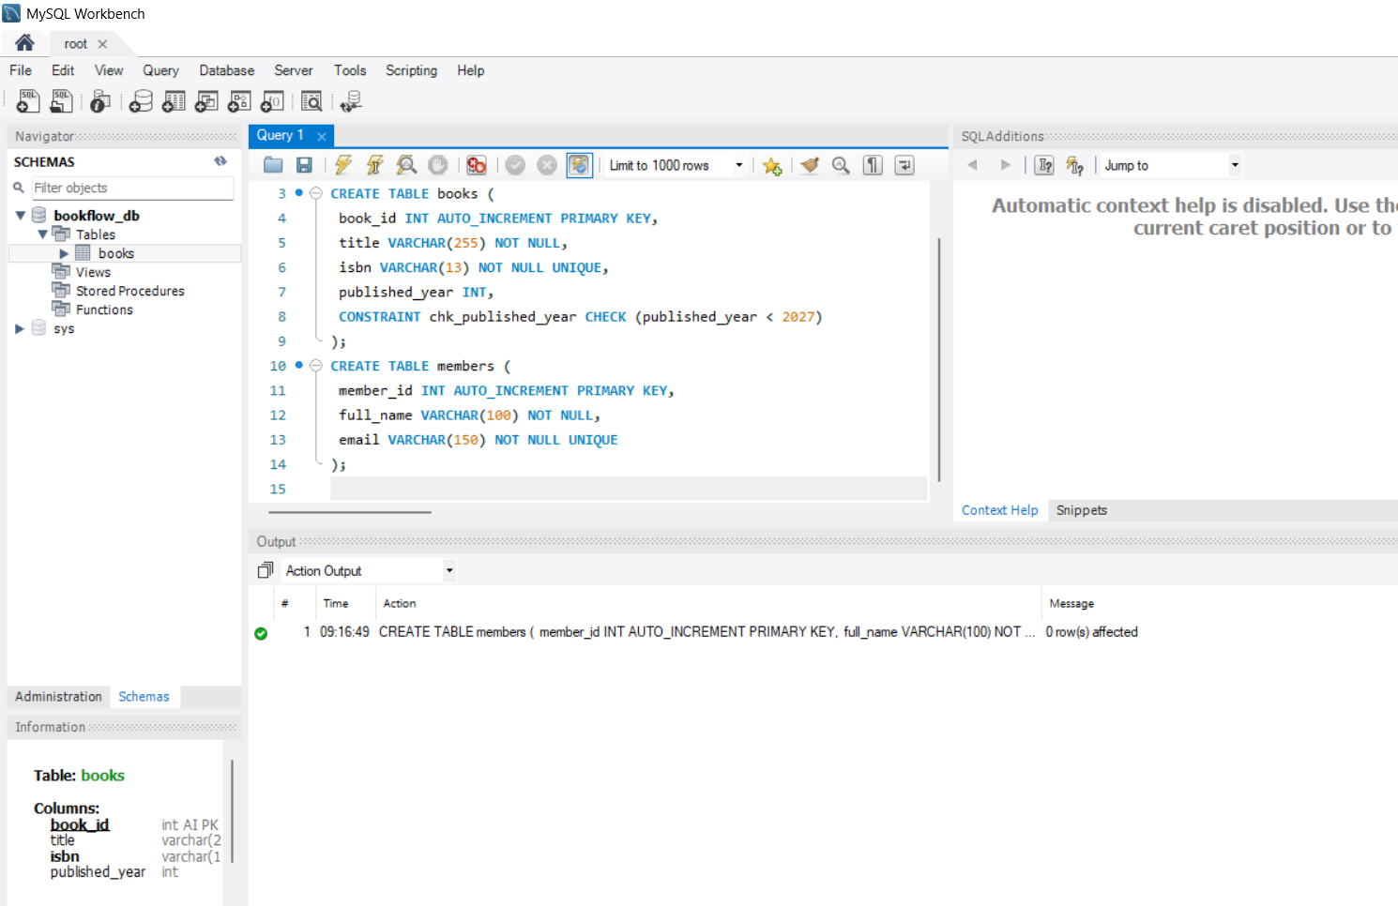Query 5 (verification): Inspect the table structures 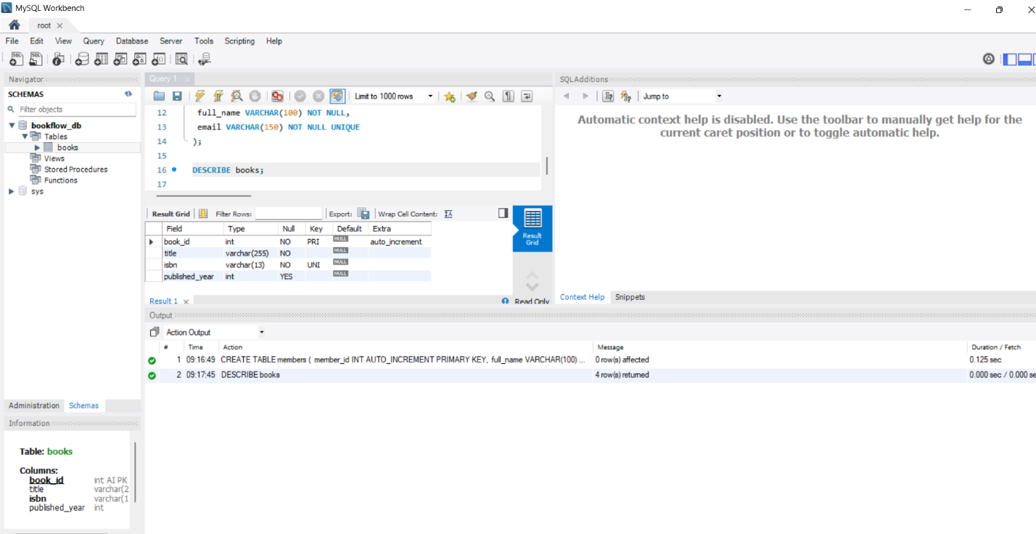Query 6: inspect the table structure (members)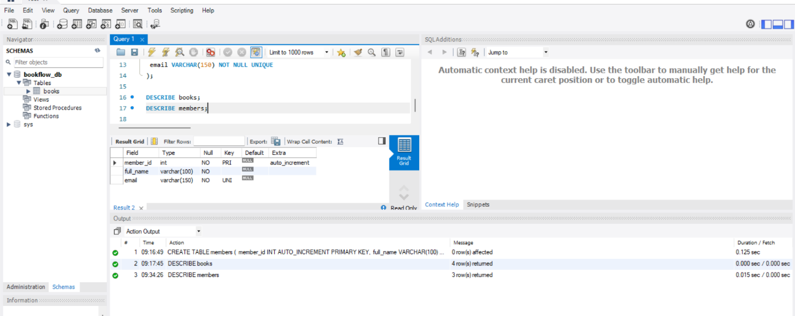
Query 7: Insert 3 books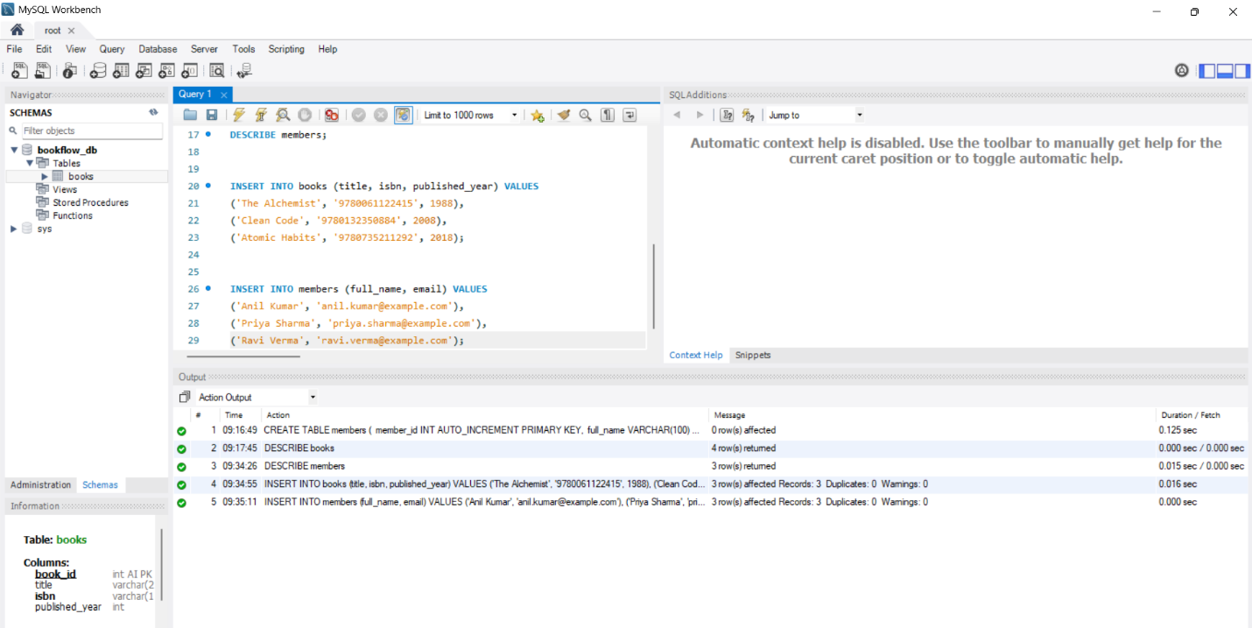Query 8: Insert 3 members 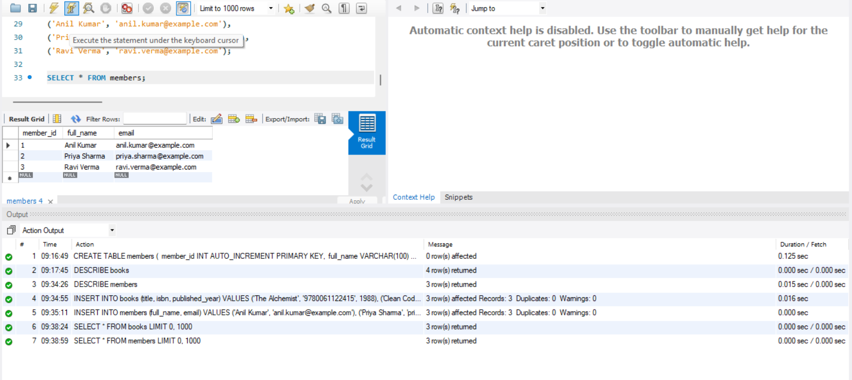

Test 1: Duplicate ISBN (UNIQUE violation)
Test 2: NULL title (NOT NULL violation)
Test 3: Future publication year (CHECK violation)
Test 4: Duplicate email (UNIQUE violation) 